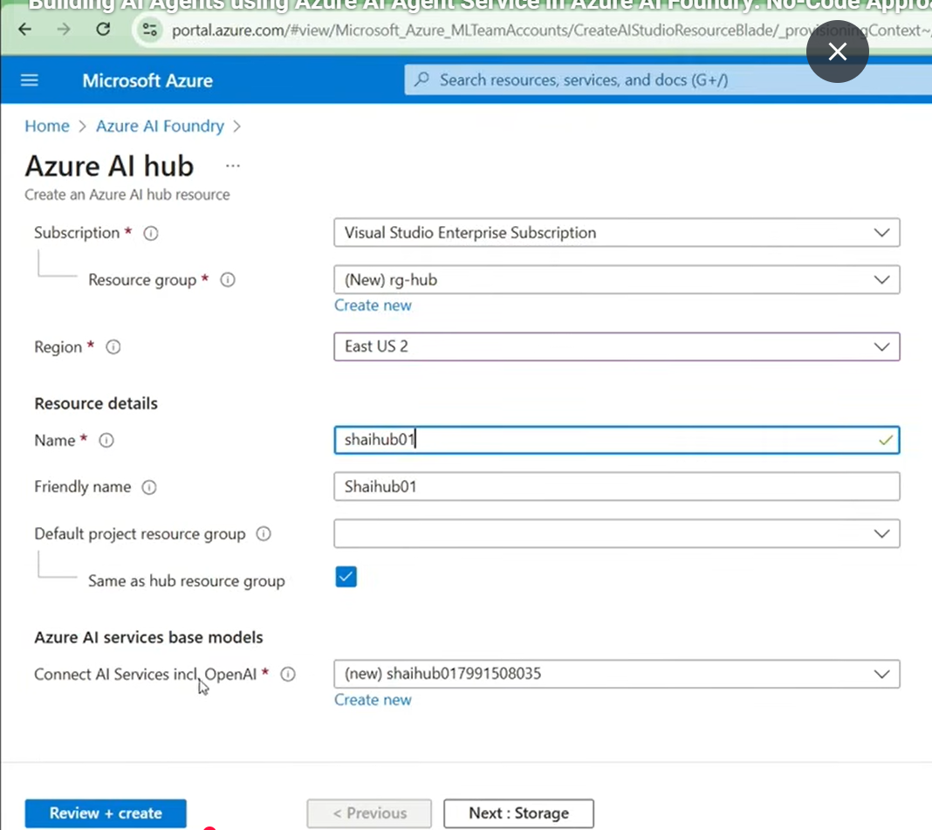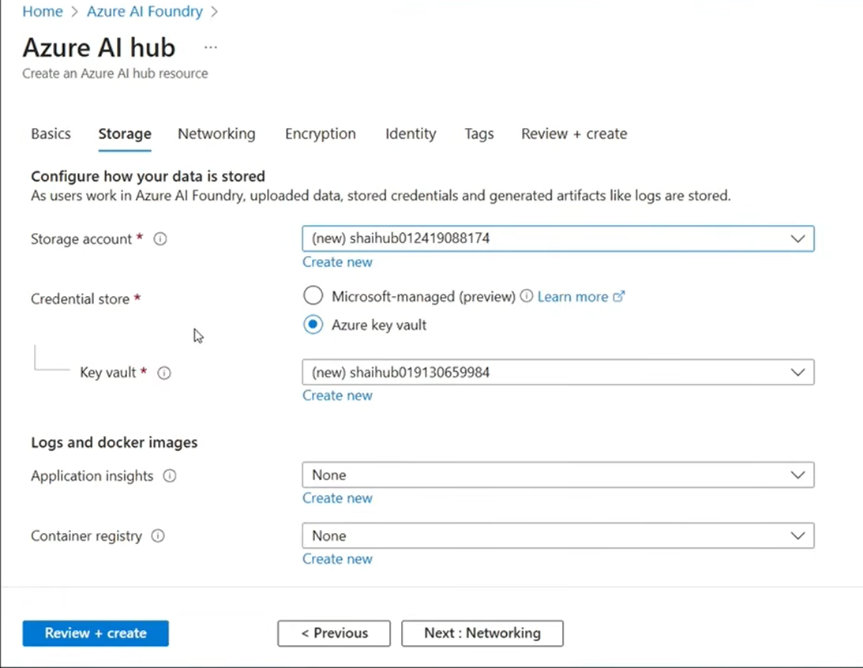
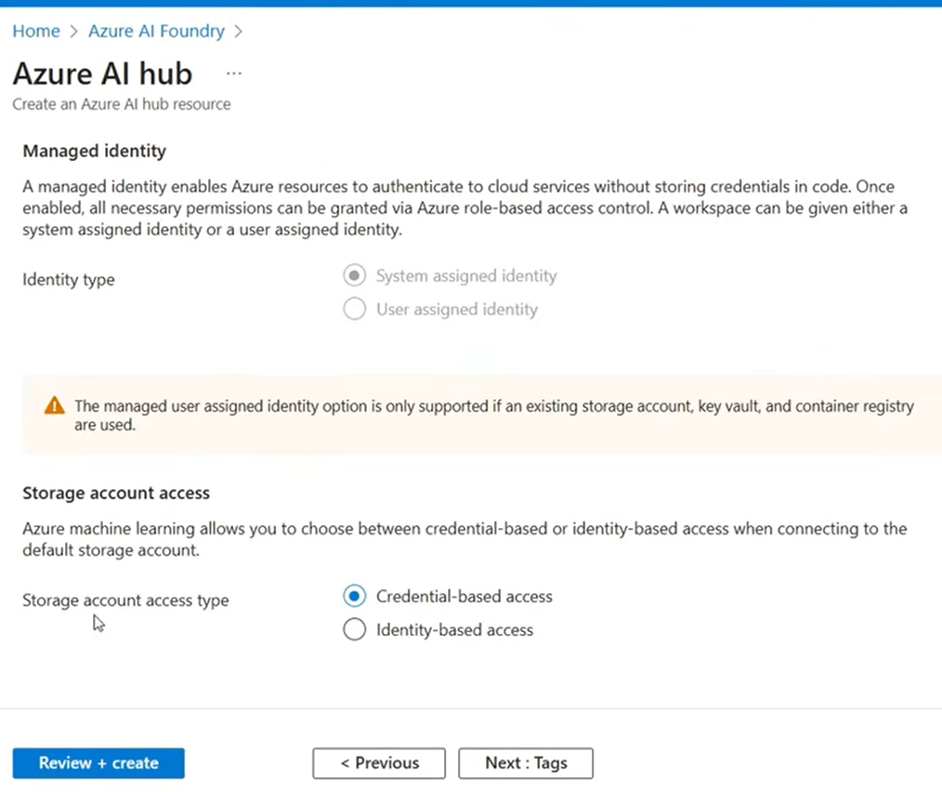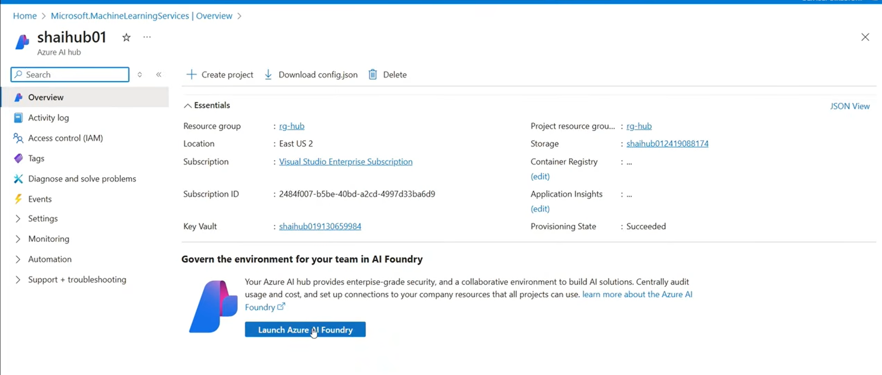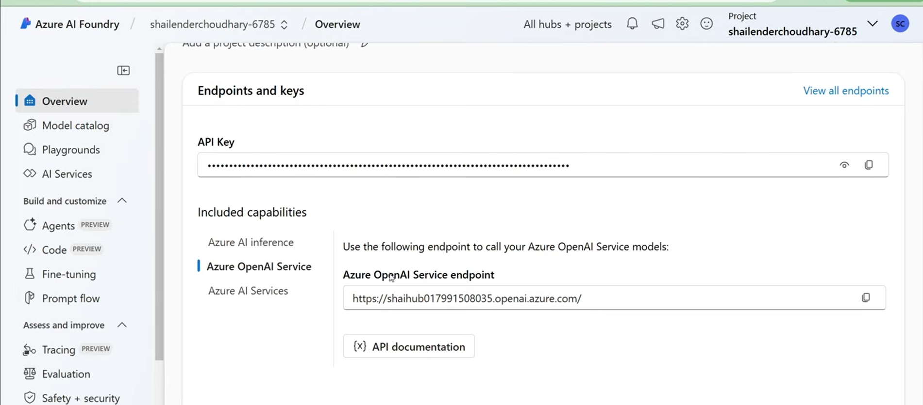

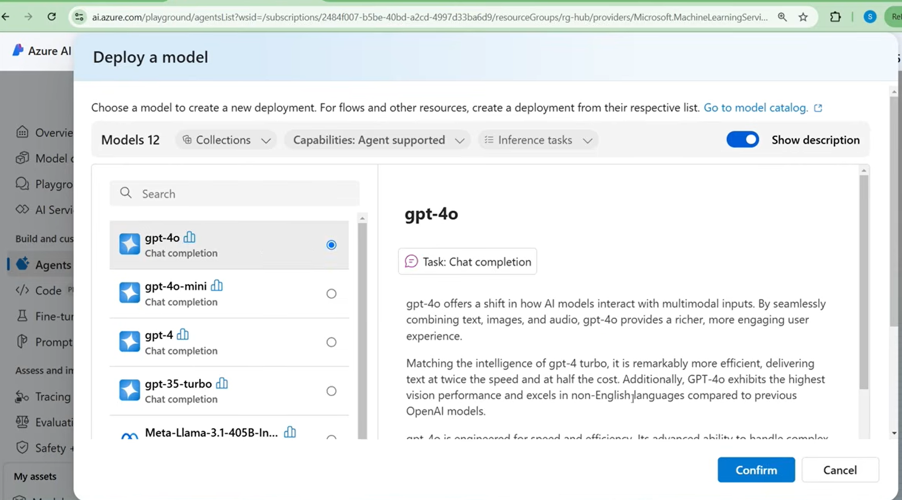
Agent ID , Agent Name, Deployment name, Knowledge, Action
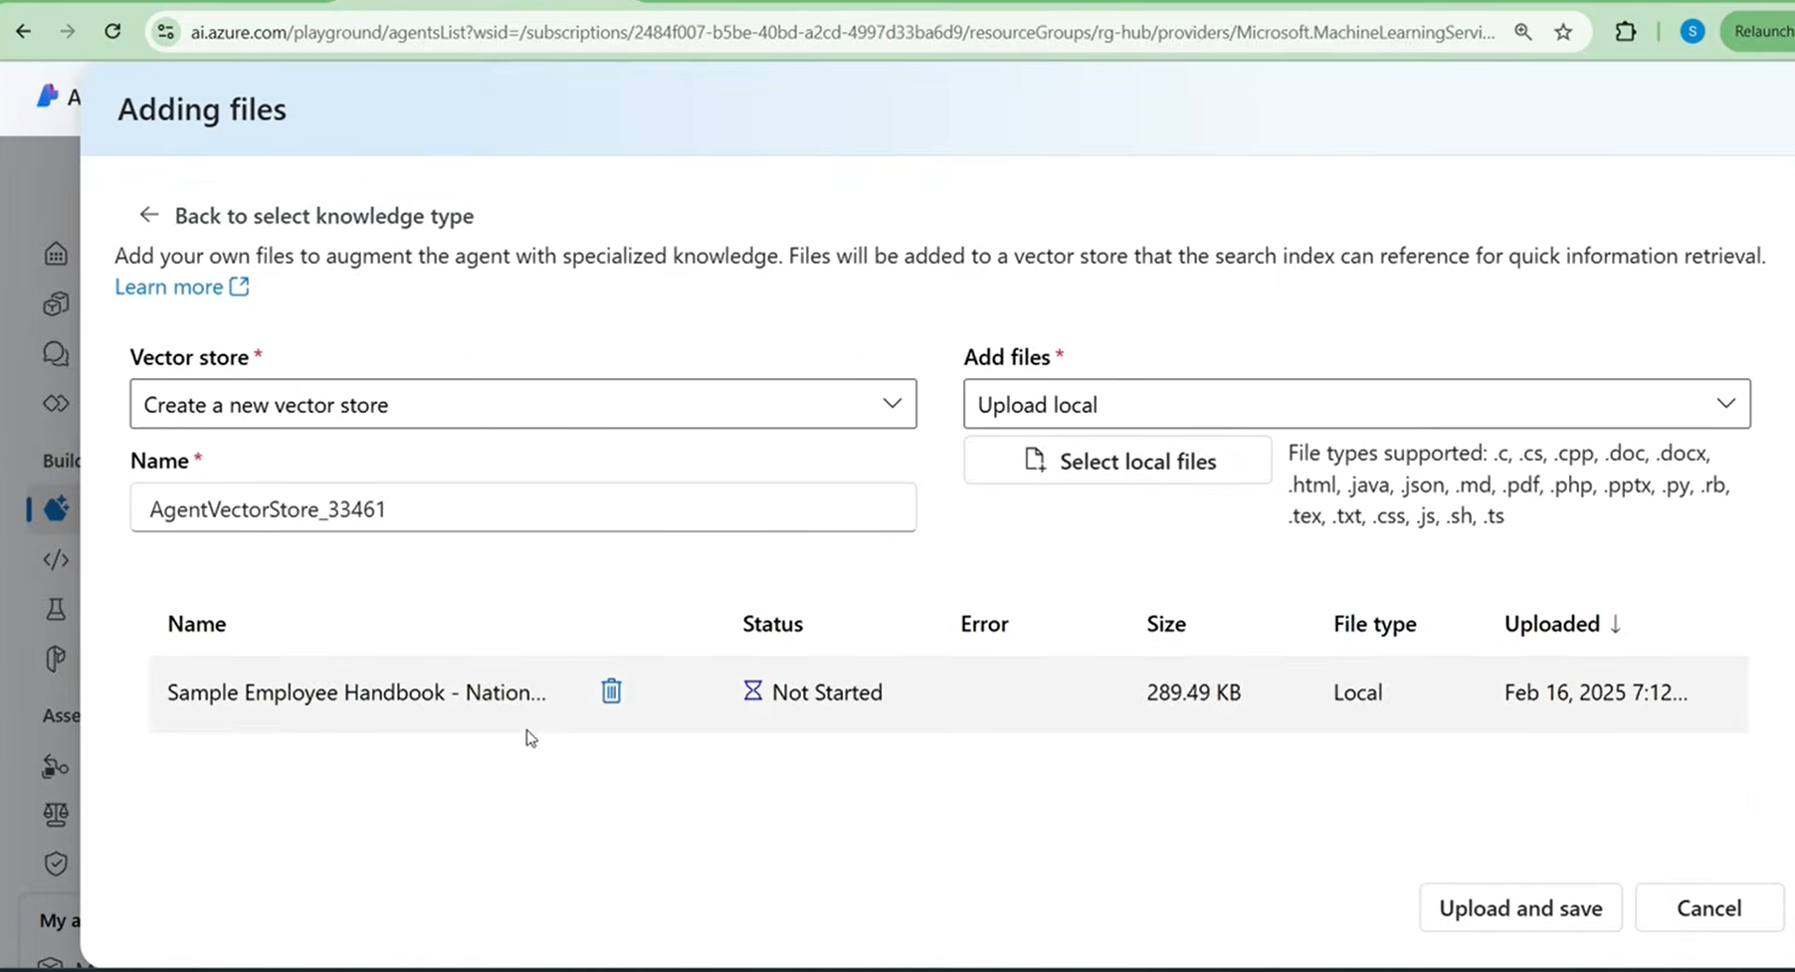
1st AGENT with Knowldge:

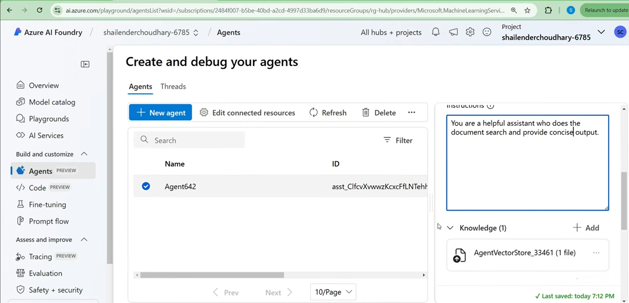

2ND AGENT with Action:
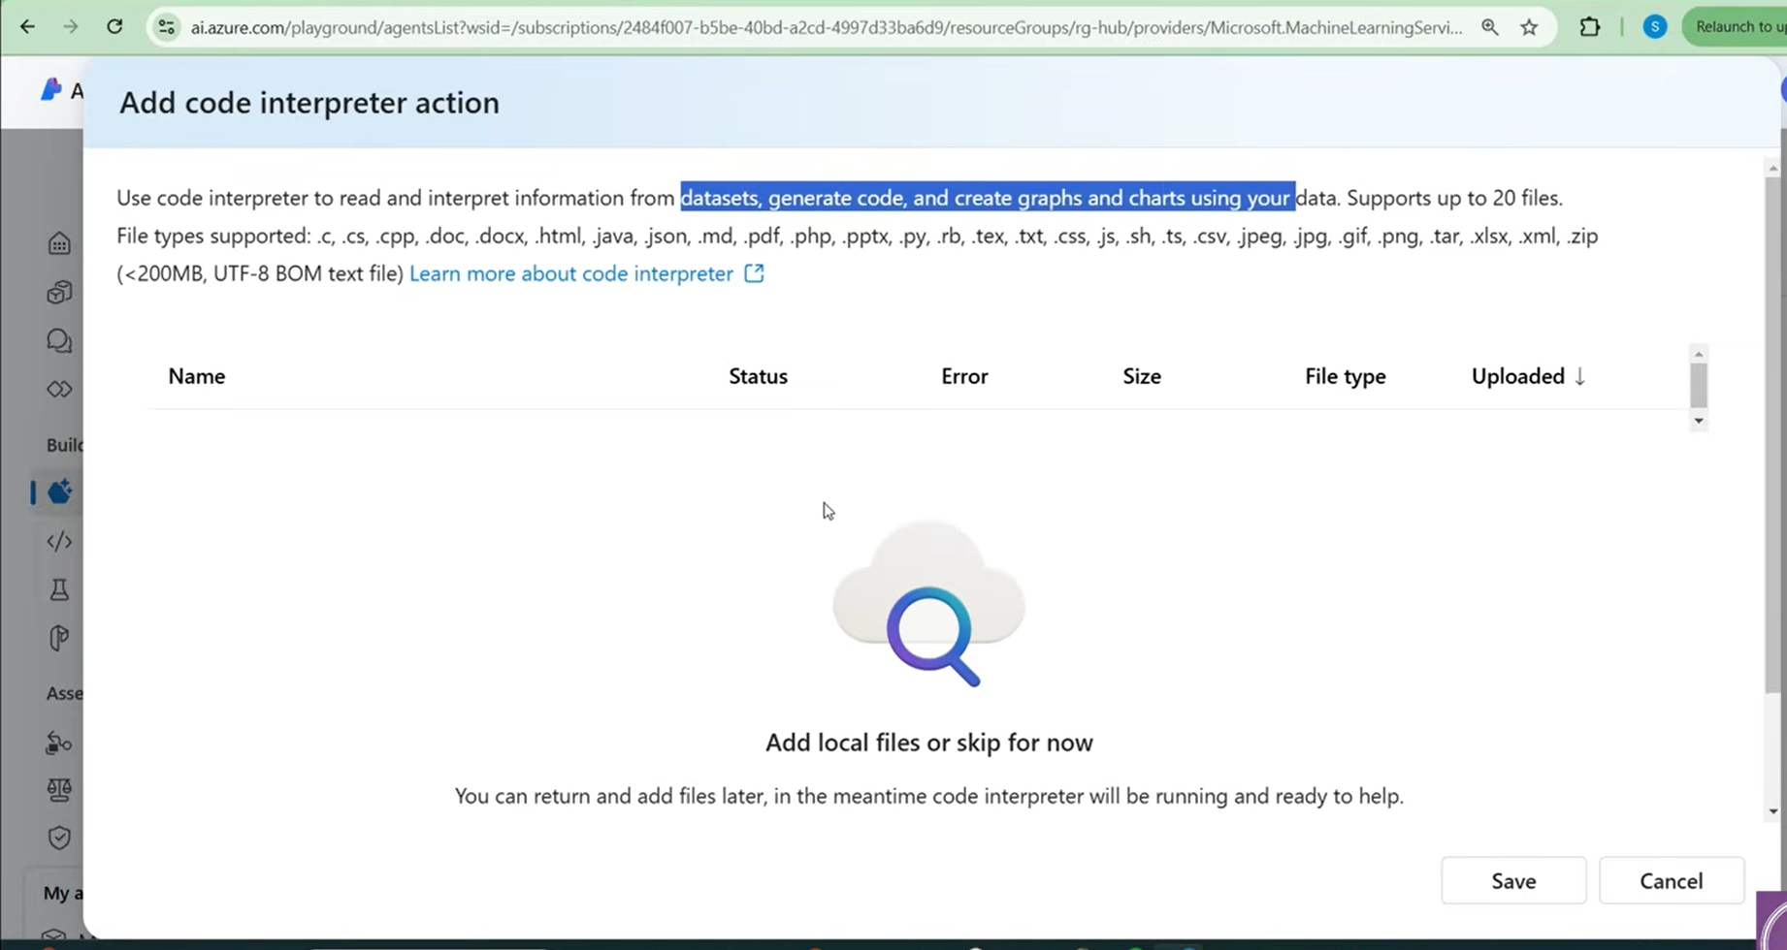
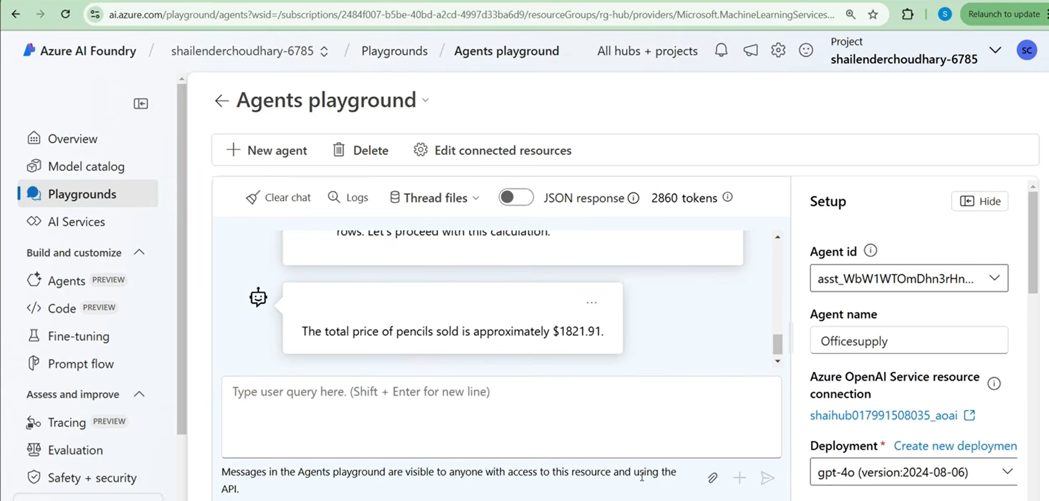

import os
import time
from azure.ai.projects import AIProjectClient
from azure.identity import DefaultAzureCredential

# Step 1: Authenticate and Initialize the Client
try:
project_client = AIProjectClient.from_connection_string(
credential=DefaultAzureCredential(),
conn_str="xxxxxxxx"
)
print("✅ Client initialized successfully.")
except Exception as e:
print(f"❌ Error initializing client: {e}")
exit()

# Step 2: Define Agent ID
agent_ids = ["xxxxxxx"] # Replace with your actual agent ID
agents = []

# Step 3: Retrieve Agent
for agent_id in agent_ids:
try:
agent = project_client.agents.get_agent(agent_id)
agents.append(agent)
print(f"✅ Agent retrieved: {agent.name}")
except Exception as e:
print(f"❌ Error retrieving agent: {e}")

if not agents:
print("❌ No agents retrieved. Exiting.")
exit()

# Step 4: Create a Communication Thread
try:
thread = project_client.agents.create_thread()
except Exception as e:
print(f"❌ Error creating thread: {e}")
exit()

# Step 5: Send a Message to the Thread
user_message = "Calculate total price for pencils."

try:
message = project_client.agents.create_message(
thread_id=thread.id,
role="user",
content=user_message
)
except Exception as e:
print(f"❌ Error sending message to thread: {e}")
exit()

# Step 6: Process Agent Runs
for agent in agents:
try:
run = project_client.agents.create_and_process_run(
thread_id=thread.id,
assistant_id=agent.id
)
except Exception as e:
print(f"❌ Error processing run for agent '{agent.name}': {e}")

# Step 7: Wait for the Agent to Process
time.sleep(10) # Increase delay if needed

# Step 8: Retrieve and Display Messages in Correct Order
try:
messages = project_client.agents.list_messages(thread_id=thread.id)

if hasattr(messages, "data") and messages.data:
# Sort messages by 'created_at' timestamp in ascending order
sorted_messages = sorted(messages.data, key=lambda x: x.created_at)

for msg in sorted_messages:
if msg.content and isinstance(msg.content, list):
for content_item in msg.content:
if content_item["type"] == "text":
print(f"🤖 {content_item['text']['value']}")
except Exception as e:
print(f"❌ Error retrieving messages: {e}")

